INSTITUTO POLITECNICO NACIONAL

Escuela Superior de Cómputo

Unit of learning

“Analog electronics”

Practice 9

“Converters digital to analog”

Group: 1CV5

Integrants

* Konishi Govantes Jorge Agustín
* Luciano Espina Melisa
* Mena Ortiz Erick Jafet
* Ortega García Francisco Javier

Introduction 3

Theorical Framework 3

DAC0800 3

TL081 4

Objectives 4

Material 4

Equipment 4

Experimental Development 5

Digital converter to analog integrated circuit 8-bit 5

R2R 6

Weighted resistances 7

Simulations 9

Questionnaire 10

Conclutions 11

# Introduction

The world real is full of signals of magnitude analog, by the opposite in the world of the computer and the electronic them signals and processes are digital. An element that transforms the signal as digital analog converter is necessary.

It is a device that performs the conversion from a continuous signal to a discrete signal, i.e. allows to digitize the signal, so that the electronic elements may interpret the signals received from the sensors. Are formed by a set of circuits comparators with different levels of stress of reference. When you apply a voltage value at the entrance, all those comparators whose reference voltage is lower than the input are activated. The output generated by these comparators is connected to a logic that encodes the output of the comparators in a value in binary format.

In everyday life we use it daily as for example, if we see a movie on DVD, the disc contains digital data, DVD converts those digital data into analog signals to be played back as audio and video. Another example more common is the PC, the information that stores is saved in format digital, the same computer the converts in signals analog to be reproduced as audio and video.

# Theorical Framework

## DAC0800

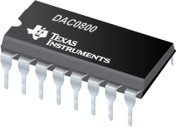There are several DAC [architectures](https://en.wikipedia.org/wiki/Hardware_architecture); the suitability of a DAC for a particular application is determined by three main parameters: [resolution](https://en.wikipedia.org/wiki/Resolution_(audio)), maximum [sampling frequency](https://en.wikipedia.org/wiki/Sampling_frequency) and accuracy. Due to the complexity and the need for precisely matched [components](https://en.wikipedia.org/wiki/Electronic_components), all but the most specialized DACs are implemented as [integrated circuits](https://en.wikipedia.org/wiki/Integrated_circuits) (ICs). Digital-to-analog conversion can degrade a signal, so a DAC should be specified that has insignificant errors in terms of the application.

DACs are commonly used in [music players](https://en.wikipedia.org/wiki/Digital_audio_player) to convert digital data streams into analog audio signals. They are also used in [televisions](https://en.wikipedia.org/wiki/Television) and [mobile phones](https://en.wikipedia.org/wiki/Mobile_phone) to convert digital video data into analog video signals which connect to the screen drivers to display monochrome or color images. These two applications use DACs at opposite ends of the speed/resolution trade-off. The audio DAC is a low speed high resolution type while the video DAC is a high speed low to medium resolution type. Discrete DACs would typically be extremely high speed low resolution power hungry types, as used in military [radar](https://en.wikipedia.org/wiki/Radar) systems. Very high speed test equipment, especially sampling [oscilloscopes](https://en.wikipedia.org/wiki/Oscilloscope), may also use discrete DACs.

## Resultado de imagen para TL081TL081

The TL08x JFET-input operational amplifier family is designed to offer a wider selection than any previously developed operational amplifier family. Each of these JFET-input operational amplifiers incorporates well-matched, high-voltage JFET and bipolar transistors in a monolithic integrated circuit. The devices feature high slew rates, low input bias and offset currents, and low offset-voltage temperature coefficient.

# Objectives

* The student will be a circuit that you help to understand better the concepts basic of a converter digital to analog implemented with an arrangement R / 2R
* The student will perform a circuit that you help to work with them converters digital to analog in circuits integrated
* The student will differentiate the implementation of a converter digital to analog with the fix R / 2R and the implemented in a circuit integrated
* Interpret the results obtained by the circuit made

# Material

* 1 Experimentation tablet operational (protoboard)
* 1 TL081
* 1 LM741
* 16 LED’s
* 2 Dipswitch of 8 positions
* 16 Resistors of 220 Ω
* 24 Resistors of 470 Ω
* 4 Resistors of 4.7 KΩ
* 10 Resistors of 1 KΩ
* 1 Capacitor of 0.01µf
* 1 Capacitor of 0.1µf

# Equipment

* Source of power triple
* Digital multimeter

# Experimental Development

## Digital converter to analog integrated circuit 8-bit

Assemble the following circuit that allows you to convert a signal digital to analog

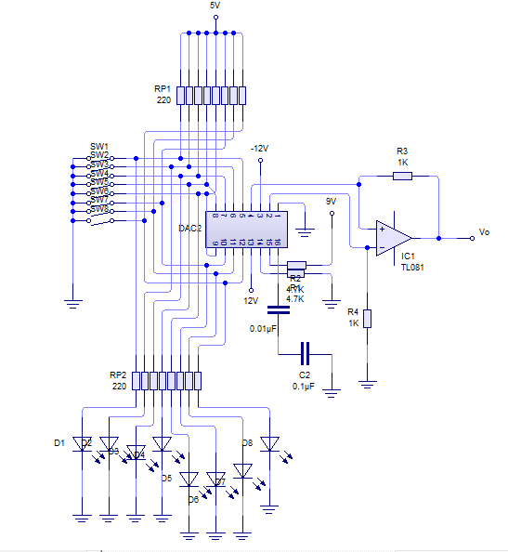

**Note: remember that you should feed the operational with ±12V**

Vary them bits of input according to the table and measure the voltage of output, scoring the voltage measured at the table

|  |  |  |  |  |  |  |  |  |  |
| --- | --- | --- | --- | --- | --- | --- | --- | --- | --- |
| D0 | D1 | D2 | D3 | D4 | D5 | D6 | D7 | (Vo) Práctico | (Vo)Teórico |
| 0 | 0 | 0 | 0 | 0 | 0 | 0 | 0 | 0 |  |
| 1 | 0 | 0 | 0 | 0 | 0 | 0 | 0 | 1.20 |  |
| 1 | 0 | 1 | 0 | 0 | 0 | 0 | 0 | 1.60 |  |
| 0 | 1 | 0 | 1 | 0 | 0 | 0 | 0 | 0.80 |  |
| 1 | 0 | 1 | 0 | 1 | 0 | 0 | 0 | 1.68 |  |
| 0 | 0 | 1 | 1 | 1 | 1 | 0 | 0 | 0.50 |  |
| 1 | 0 | 0 | 0 | 1 | 1 | 1 | 0 | 1.40 |  |
| 1 | 1 | 1 | 1 | 0 | 1 | 1 | 0 | 2.41 |  |
| 0 | 0 | 0 | 0 | 0 | 0 | 0 | 1 | 9.82 |  |
| 0 | 1 | 0 | 0 | 0 | 0 | 0 | 1 | 0.08 |  |
| 0 | 1 | 1 | 0 | 0 | 0 | 0 | 1 | 1 |  |
| 1 | 0 | 1 | 1 | 0 | 0 | 0 | 1 | 1.75 |  |
| 0 | 1 | 1 | 0 | 1 | 0 | 0 | 1 | 1.04 |  |
| 0 | 1 | 0 | 1 | 1 | 1 | 0 | 1 | 0.92 |  |
| 1 | 0 | 1 | 1 | 0 | 1 | 0 | 1 | 1.87 |  |
| 1 | 1 | 1 | 1 | 1 | 1 | 1 | 1 | 2.58 |  |

Determine the value of the Bit less significant (LSB)

**01000001**

## R2R

|  |  |  |  |  |
| --- | --- | --- | --- | --- |
| D0 | D1 | D2 | D3 | VO |
| 0 | 0 | 0 | 0 | -332.1 |
| 0 | 0 | 0 | 1 | -665 |
| 0 | 0 | 1 | 0 | -1.03 |
| 0 | 0 | 1 | 1 | -1.3 |
| 0 | 1 | 0 | 0 | -1.64 |
| 0 | 1 | 0 | 1 | -2.01 |
| 0 | 1 | 1 | 0 | -2.3 |
| 0 | 1 | 1 | 1 | -2.6 |
| 1 | 0 | 0 | 0 | -3.1 |
| 1 | 0 | 0 | 1 | -3 |
| 1 | 0 | 1 | 0 | -3.4 |
| 1 | 0 | 1 | 1 | -4 |
| 1 | 1 | 0 | 0 | -4.1 |
| 1 | 1 | 0 | 1 | -4.5 |
| 1 | 1 | 1 | 0 | -4.1 |
| 1 | 1 | 1 | 1 | -5 |

## Weighted resistances

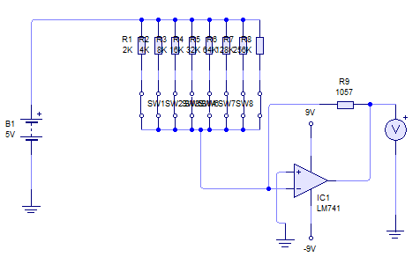

|  |  |  |  |  |  |  |  |  |
| --- | --- | --- | --- | --- | --- | --- | --- | --- |
| D0 | D1 | D2 | D3 | D4 | D5 | D6 | D7 | V0 |
| 1 | 1 | 0 | 0 | 1 | 1 | 0 | 0 | -260mV |
| 0 | 1 | 0 | 0 | 0 | 0 | 1 | 0 | -85mV |
| 0 | 1 | 0 | 0 | 0 | 0 | 0 | 0 | -1.41V |
| 0 | 0 | 0 | 0 | 0 | 1 | 0 | 1 | -64.2mv |
| 1 | 0 | 0 | 0 | 0 | 1 | 0 | 1 | -1.7V |
| 1 | 0 | 1 | 0 | 1 | 0 | 1 | 0 | -2.2v |
| 0 | 1 | 1 | 1 | 1 | 1 | 0 | 0 | -1.6V |
| 0 | 1 | 0 | 0 | 1 | 0 | 1 | 1 | -97Mv |
| 1 | 0 | 1 | 1 | 0 | 1 | 0 | 0 | -2.52V |
| 1 | 1 | 1 | 0 | 0 | 0 | 0 | 1 | -2.56V |
| 0 | 0 | 1 | 1 | 0 | 1 | 0 | 1 | -1.38V |
| 1 | 1 | 0 | 1 | 1 | 0 | 0 | 0 | -2.7V |
| 1 | 0 | 0 | 1 | 1 | 0 | 0 | 0 | -1.6V |
| 1 | 1 | 0 | 0 | 1 | 0 | 1 | 0 | -2.6V |
| 0 | 1 | 0 | 1 | 0 | 1 | 0 | 1 | -1.1V |

# Simulations

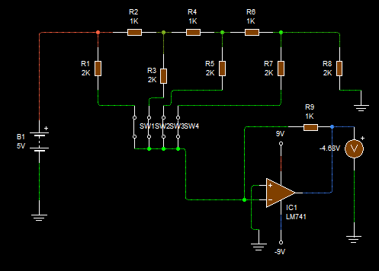

Simulation of R2R

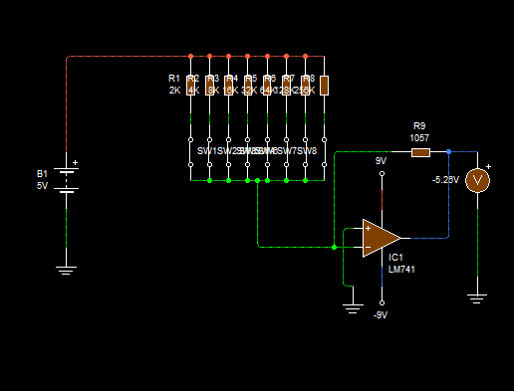

Simulation of Weighted resistances

# Questionnaire

1. **What difference there is between a converter digital to analog with resistances weighted and one R / 2R?**

A network R-2R allows a shape simple and economic of implement a converter digital-analog (DAC), linking groups of resistances of precision alternating the two values possible in a staircase. Unlike the weights weighted DAC, the network R-2R only needs two values of resistances. What it makes much more simple.

1. **What advantage does the DAC reinforced resistances and Assembly with integrated circuit?**

Obviously is the simplicity of the connection of the circuit integrated, since for the dac is a little more complicated by so many connections

1. **What is the time of establishment in a converter digital to analog?**

The time of establishment of a DAC converter has two components: one due to the linear dynamic behavior and the other because of the Slew-Rate of the op-amp (non-linear phenomenon). The first is must to them capabilities parasitic in parallel with them keys electronic, that make that the switching between a code of entry and another not be instant. Its features are similar to the of any transient, with an exponential approximation to the final value. The component due to the slew-rate of the amplifier is characterized by a linear growth with fixed slope, so the greater the amplitude of the jump (e.g. a change in entry of 00... 0 to 11... 1) the greater the time of growth. General predominates the effect of the slew-rate, unless you use amplifiers of very high speed.

1. **What are the differences generated between the values of the two circuits made in practice?**

because you use a dac which consumed differently to the operational voltage, in the second we say was consumed more because in addition to the dac used the TL081

# Conclutions

### Konishi Govantes Jorge

### Luciano Espina Melisa

It was more difficult this practice, since first connections were a little confusing, or at least my was me complicated at first, then the teacher said "already do the first, best of class" and was a little ugly because it had already finished assembling the circuit, so we started to assemble the other circuit practice and subsequently the class , is interesting see as is performs the conversion of signals, if I helped to understand better it explained in class, also is noted the difference between them different circuits and them values that threw the circuit

### Mena Ortíz Erick Jafet